Name: __________________________________________ Period: ______ Date: ___________

**CP 2D Motion Test Review**

Question 2

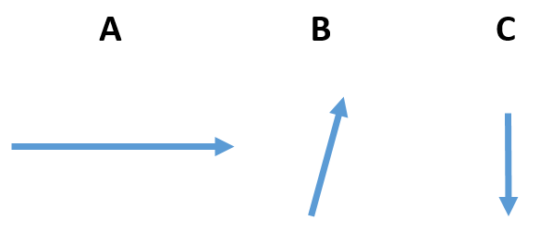

1a. 23 m/s **east** is a vector. What are the two parts that make up a vector?

Underlined is the ________________

Bolded is the ____________________

1b. Rewrite the information in 1a as a scalar quantity

2a. Which vector has the greatest south component?

2b. Which vector has the greatest magnitude?

Question 3a. Draw the path of the fish dropped to the target

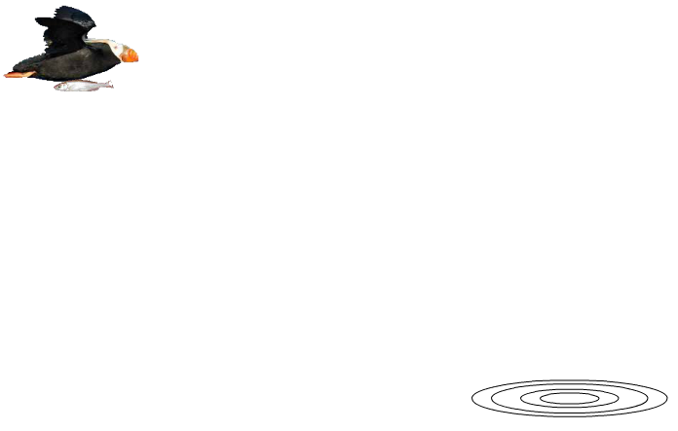

3. A bird is flying horizontally when it drops a fish. 3a. Draw the path the fish would take. 3b. This shape is called a _______________________

3c. When would the bird have to drop the fish to hit the target? (before, directly above, or after)

3d. Where will the bird be when the target is hit? (before, directly above, or after)

Horizontal Projectile Motion Practice

4. A bird is flying at 25 m/s when it drops the fish that falls 90 meters to the water.

4a. How long does it take the fish to fall to the water?

4b. How fast is the fish traveling vertically when it hits the water?

4c. How far horizontally forward will the fish land?

4d. What variable information was given in the question which was required to determine how far out the fish would land?

4e. Would the mass of the fish affect the time it takes to hit the ground?

5. Give three examples of a projectile?

6a. What happens to horizontal velocity after a projectile is launched horizontally?

6b. What happens to vertical velocity after a projectile is launched horizontally?

6c. Which is effected by gravity? (vertical motion or horizontal motion)

7a. You throw a ball forward at 20 m/s from a height of 1 meter. How much time would it take to hit the ground?

7b. You drop a ball from a height of 1 meter. How much time would it take to hit the ground?

7c. The faster you throw a ball horizontally (increases, decreases, does nothing) to the time it takes to hit the ground?

Question 8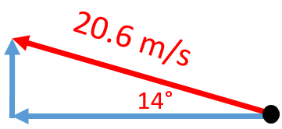

8a. What would be the complete description of the vector drawn here?

8b. What is the horizontal component of the vector drawn here?

8c. What is the vertical component of the vector drawn here?

9. What is the resultant of going 35 m west followed by 60 m north? Draw a complete vector diagram with arrow tips. Give a complete answer with magnitude, direction, and description of that direction.

**Angular Projectile Motion Questions**

10. What angle would you shoot a projectile to have it reach the furthest distance downrange?

Question 11

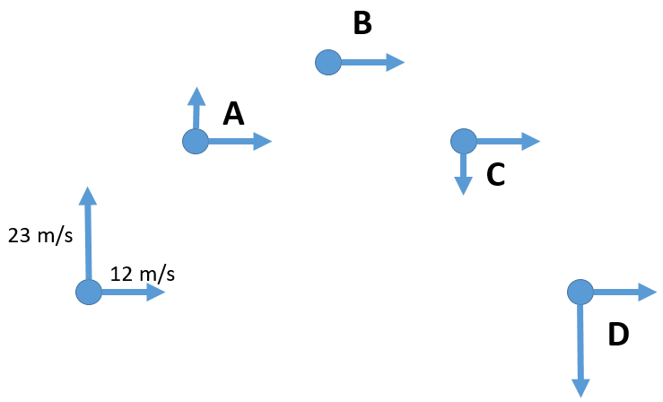

11a. What is the horizontal velocity at C in the projectile diagram?

11b. Where is the minimal velocity and what would that be?

11c. What is the vertical velocity at point D?

11d. What is the horizontal velocity at point D?

11e. What is the acceleration at B?

11f. What is the vertical velocity at B?

11g What is the horizontal acceleration when the ball maintained a constant horizontal velocity of 12 m/s for 4.6 seconds?

11h what is happening to the vertical speed on the way up?

11i. What is happening to the vertical speed on the way down?