Name: ___________________________ Period: _____ Date: __________
Lens Ray Diagrams and Images Description
Concave Lens (Diverging Lens)

1. Describe the Image Produced:

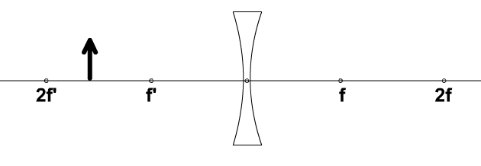

2. Describe the Image Produced:

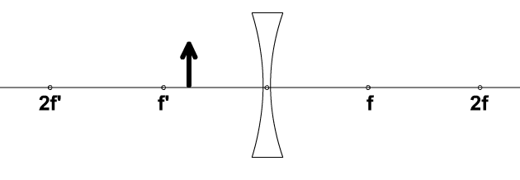

Convex Lens (Converging Lens)
3. Describe the Image Produced:
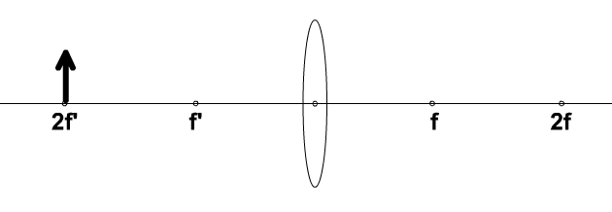

4. Describe the Image Produced:

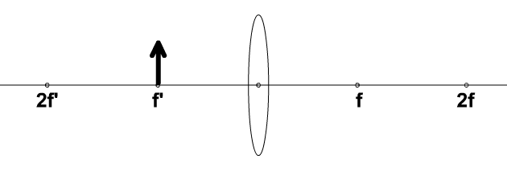

5. Describe the Image Produced:
