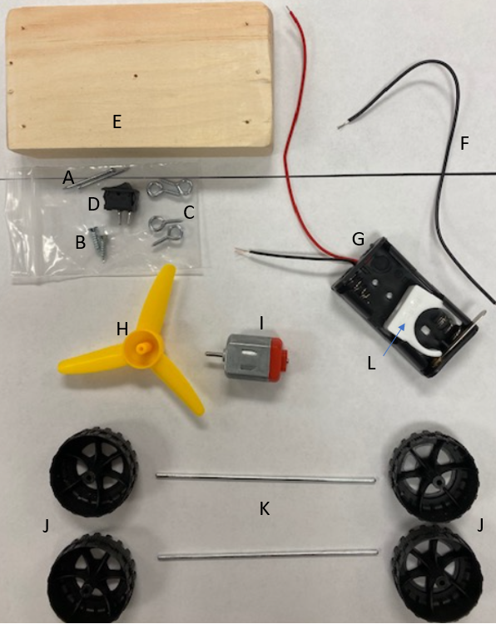
Name: _____________________________ Period: ______ Date: _______
Propeller Car

Parts:
A: #17 x 1 in. Wire Brads (nails) (2 ct.)
B: #4 x ½ in Wood Screws (2 ct.)
C: #216 Screw Eyes (4 ct.)
D: Switch
E: Wood Block
F: Wire
G: Double AA Battery Holder
Note: The colors of your wires, black or red, will not matter
H: Propeller
I: Motor
J: Wheels (4 ct.)
K: Axle (2 ct.)
L: Motor Clip

Other tools needed: mini Phillips screwdriver, mini hammer (optional), solder and solder gun (optional)

BOTTOM OF THE CAR
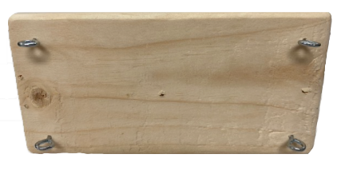
When you begin to put together the propeller car, holes are drilled so either side can be the top or the bottom. Pick one to be the bottom.

I. On the four corner holes of the wood base use (part C) the 4 screw eyes, they should be twisted in until you do not see the screw threads. Leave the heads screwed in at the same height and horizontal to the long dimension of the board as you see in the picture.
I
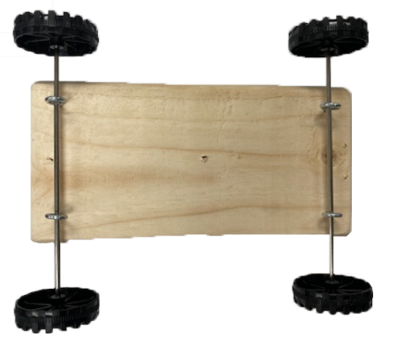
III
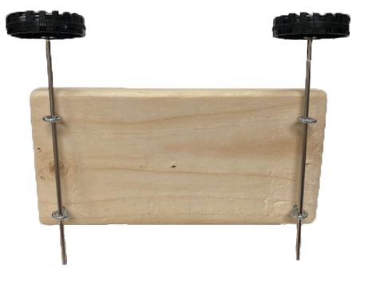
II. Next put a wheel (Part J) on one side of an axle (Part K) and slide it through the screw eyes from part I for the front axle. Then do the same for the back axle so it appears as you see in the picture.

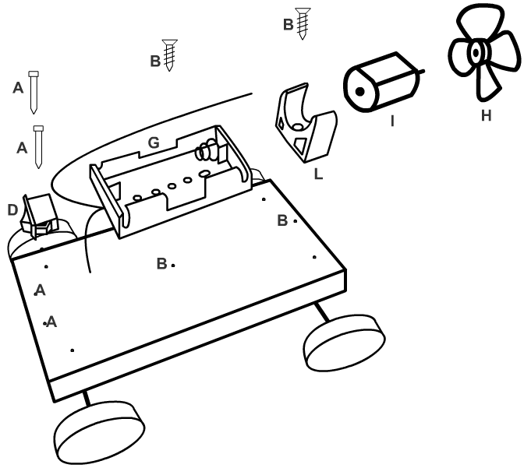
III. Now add the other wheel to each axle so you have a wood base on two completed axles. Carefully push the wheels together on each side of the axle so the wheels are firmly in place as seen in the picture.
II

TOP OF THE CAR
Now we are ready to put together the top components of the propeller car that will include a direct current closed circuit with two batteries, a switch, and a motor

On the next page you will find step by step directions.

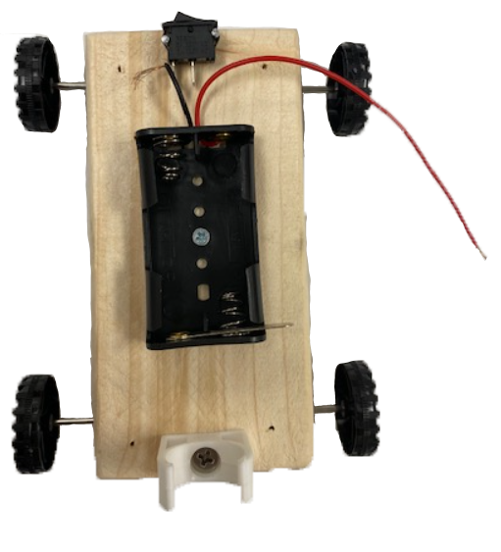
IV. Use the wire braids (part A) to secure the switch (Part D) into place. You should find a triangle shaped opening where the wire braids can fit through the switch. Use a hard surface or mini hammer to secure the switch in place.
VI

V. Use the wood screw (part B) to secure the double battery holder (part G) to the wood base with the wire leads facing the switch. Use the center hole of the battery holder for the wood screw as seen in the picture.
V
VI. Use a wood screw (part B) to secure the motor clip (part L) to the back end of the wood base so the length of the motor clip is perpendicular to its closest side as see in the picture.

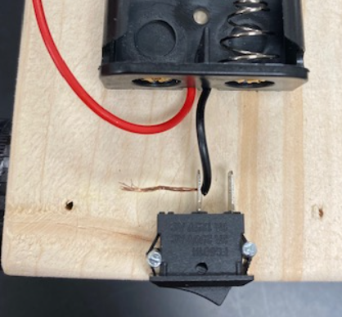
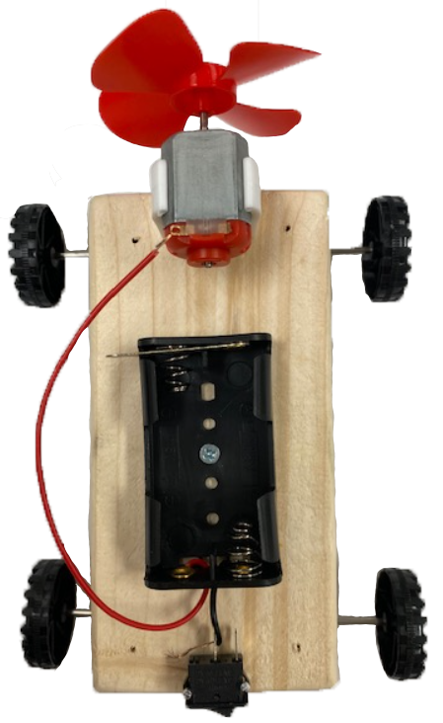
VII. With the car switch facing towards you, thread the uninsulated part of the right battery holder wire through the left electrode (metal part with a hole the wire goes through) from the inside out as you see in the picture.
IV

VIII. Push the shaft of the motor (part I) into the propeller (part H) hole so the propeller is securely attached to the motor. Then place the motor with propeller into the motor clip so the propeller is free to rotate behind the wood block body.
VII

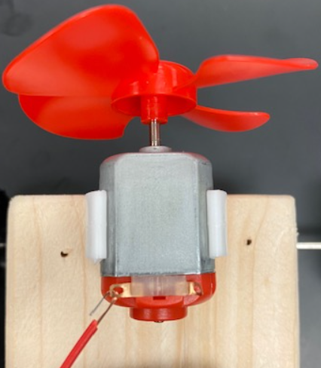
IX. Take the left battery holder wire and thread it from inside out of the left electrode on the motor as seen in the picture.

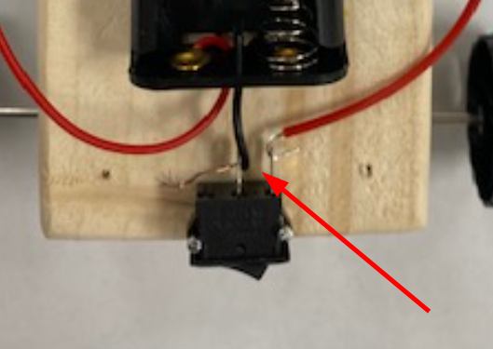
X. Take the wire (part F) and thread one uninsulated side from inside out on the right electrode of the motor. Take the other uninsulated side of the wire and tread it from the inside out of the right electrode on the switch.
IX
VIII

Be sure the wire through one electrode is not touching the other electrode or its wire. You do not want a conductive path bypassing the switch or the motor would stay on.
X

Place the batteries correctly in the battery holder.
No wire should be touching both electrodes
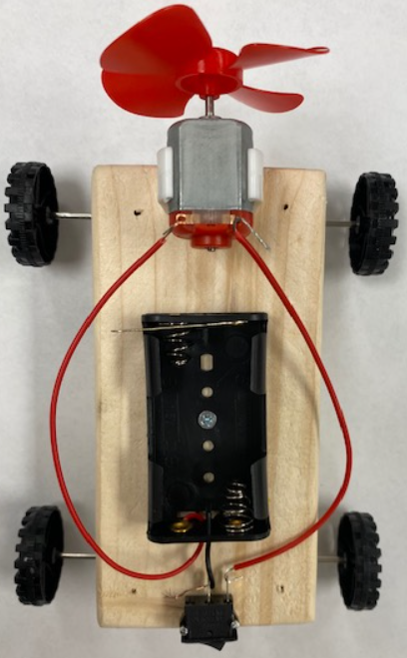
If the propeller is blowing outwards the car should accelerate forward when on. If the propeller is blowing the wrong way and the car does not move, switch the leads into the motor and the propeller will switch and blow the right way to make your car go.
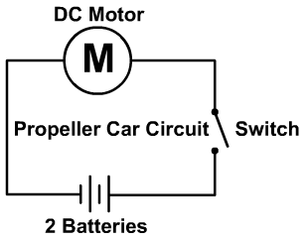
Here you see the circuit diagram you created with a direct current motor, switch, two batteries, and conductive wire.

You may need to trouble shoot the alignment of any of the axle screws if your car is not driving straight
Finished car

